**Excel Assignment – 7**

**1. Using Insert Function, give examples of any function available in the**

**different dropdowns present in the function library. For example**

**AutoSum, Recently Used, Text, Date & Time, etc.**

-1.AutoSum

SUM: Adds a range of cells together.

AVERAGE: Calculate the average of a range of cells

COUNT: Counts the number of cells in a range that contains numbers.

MAX: Returns the maximum value from a range of cells.

MIN: Returns the minimum value from a range of cells.

2. Recently Used: This dropdown displays a list of recently used functions,which may vary based on your usage.

3. Financial:

- PMT: Calculates the periodic payment for a loan based on constant payments and a constant interest rate.

- FV: Calculates the future value of an investment based on periodic constant payment and a constant interest rate.

- NPV: Calculates the net present value of an investment based on a series of periodic cash flows and a discount rate.

4. Text:

- LEFT : Extract a specified number of characters from the beginning of a text string.

-RIGHT: Extract a specified number of characters from the end of a text string

-MID: Exctract a specified number of characters from a text string, starting at a specific position.

-CONCAT: Combines multiple text string into one.

5. Date and Time:

- TODAY: Returns the current date.

- NOW: Returns the current data and time.

- YEAR: Extract the year from given date.

- MONTH: Extract the month from a given date.

-DAY: Extract the day of month from given date.

**2. What are the different ways you can select columns and rows?**

- To select the entire column, click on the column letter at the top of column, then press Ctrl+Spacebar. To select the entire row,click on row number on the left side of the row, then press Shift+ Spacebar

**3. What is AutoFit and why do we use it?**

- Autofit is a feature in Excel that allows you to automatically adjust the width of a column or the height of a row to fit the contents within it.

Why to use the Autofit feature.

-1. Content Visibility: AutoFir ensures that all the data within a column or row is fully visible. If the content is wider or taller than column or row, it may be cut off or displayed with ellipses. By using the autofit you can resize the column or row row to accommodate the complete content, making it fully visible to users.

2. Enhanced Readability: AutoFit helps improve the readability of the data in Excel. By adjusting the column width or roe hright to fit the content, all text is displayed on its entirely, making it easier for user to view and understand the data.

3.Handling the dynamic data: AutoFit is particularly useful when working with dynamic data that may change or be updated regularly.

4. Printing and Presentation: Autofit helps in preparing worksheet for printing or creating presentations, By using Autofit , you can ensure that the printed or displayed version of your spreadsheet appears well-organized, with all content clearly visible with the available space.

**4. How can you insert new rows and columns into the existing table?**

1. Select the cell in the table where you want to insert the new rows or column, This cell should be part of the existing table.

2. To insert a new row: Right-click on the selected cell and choose “Insert” from the context menu. Alternatively ,go to the “Home”tab on the ribbon , click on the “Insert” button the cells group and choose “Insert sheet rows”

3. To Insert a new column: Right –click on the selected cell and choose “Insert” from the context menu. Alternatively ,go to the “Home”tab , click on the “Insert”button in the cell group and chose “Insert sheet column”.

**5. How do you hide and unhide columns in excel?**

- To hide column:

1.Select the columns that you want to hide. You can do this by clicking the column letter at the top of the column.

2.Right-click on any of the selected column headers,and context menu will appear.

3. In the context menu,click on “Hide” to hide selected column.

- To unhide column:

1. Select the adjacent column on the both sides of the hidden column.

2. Right- click on the selected columns and context menu will appear.

3. In the context menu, click on the “Unhide” to reveal the hidden column

**6. Create an appropriate table within the worksheet and use different**

**functions available in the AutoSum command.**

* Open a new worksheet in Excel.
* Enter the following data into cells A9 to C9.

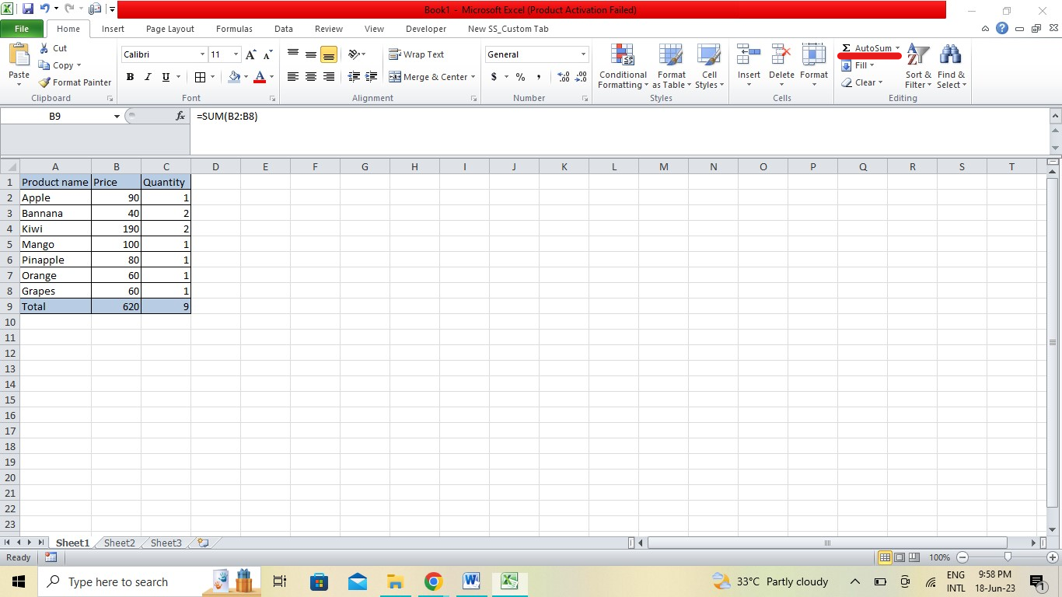

* Select cell B2 to C8.
* Click on the “AutoSum” button in the “Editing” group in the “Home” tab of the ribbon. It is located next to the “Inset funcation” button.
* Excel will automatically insert the SUM function in the selected cell. The formula will appear as = SUM(B2:B8). Similarly select cell C2 to C8.
* Click on thee “Autosum” button again.
* As a result, the total price and total quantity will be calculated and displayed in cell B9 and C9.